

Term paper

“Impact of Capital Structure on Profitability: Evidence from Indian Companies.”

Submitted by –
Sudeep Kashyap M R
PES1PG24MB441
III Trimester, MBA

Submitting to-
Arvind LN
Assistant Professor
Department of Management and Commerce

Abstract-
This study examines the impact of capital structure on the profitability of selected Indian companies across multiple sectors over a ten-year period. Profitability, measured through Net Profit Margin (NPM), is analysed against firm-specific financial indicators including Return on Equity (ROE), Sales, Equity, and the Debt-to-Equity (D/E) ratio. Regression analysis was employed to quantify the relationship between capital structure and profitability. The findings reveal that ROE and Equity have a strong positive influence on profitability, while Sales show a negative effect, suggesting that higher revenues do not always guarantee higher margins. The D/E ratio demonstrates a modest positive impact, indicating that balanced leverage can support profitability but excessive debt may increase financial risk. The results underscore the importance of maintaining an optimal mix of debt and equity to enhance financial performance. These insights are valuable for managers in making financing decisions, investors in evaluating company stability, and policymakers in promoting sound financial practices.

Introduction-
Profitability is a key goal for any business, as it indicates how well a company is doing and if it can survive in the long term.
For managers, investors, and policymakers, knowing what impacts profitability is crucial for making wise financial and strategic choices. One major factor that directly affects profitability is capital structure—the combination of debt and equity a company uses to fund its operations and growth.
Decisions about capital structure are vital because they influence the cost of capital and the level of risk a company takes on. If a company takes on too much debt, it might benefit from tax advantages but also face high interest payments, which can lower its profits. Conversely, if a company depends solely on equity, it may achieve more financial stability but could miss the benefits of debt financing. Thus, finding the right balance between debt and equity is crucial for enhancing profitability.
In India, this subject is particularly important as companies work in a changing environment influenced by economic shifts, competitive markets, and regulatory changes.
Indian businesses, whether in manufacturing, services, or consumer sectors, must make careful financing choices to stay profitable and sustainable. The success of companies in sectors like banking, automobiles, and fast-moving consumer goods indicates that profitability involves not just increasing sales but also effectively managing and financing resources.
The companies chosen for this study include a variety of established Indian firms from different sectors. These businesses face the task of managing their capital structures to support growth while maintaining stable profitability. For instance, larger companies might find it easier to access debt and equity markets, yet they still have to determine the right mix of financing to optimize returns. Conversely, smaller firms may rely more on equity or internal funds due to limited access to external financing. In both scenarios, the balance between debt and equity is crucial for determining profitability.
Examining the connection between capital structure and profitability in Indian firms can yield valuable insights for both managers and investors. For managers, this understanding can lead to improved financing decisions that enhance profitability and shareholder value. Investors can benefit from this knowledge by evaluating the financial stability and risk of companies prior to making investment decisions. Additionally, policymakers can use these findings to develop regulations that promote sound financing practices within the corporate sector.
In this regard, the current paper aims to analyze how capital structure affects the profitability of selected Indian companies. The research underscores the significance of balanced financing decisions and the influence of debt and equity on profit results. Although each company has its distinct circumstances, the overall trend indicates a strong correlation between financing choices and profitability, as well as overall financial performance.

Literature Review-

1.Capital Structure and Profitability of Listed Firms in Ghana Abor (2005)-
Abor investigated the relationship between debt ratios and profitability for listed firms in Ghana. The study revealed that short-term debt had a positive impact on profitability, while long-term debt reduced returns. This indicated that debt maturity plays a crucial role in determining financial performance. The research highlights the importance of balancing debt structure, which is also reflected in your dataset through the debt-to-equity ratio.
2.Determinants of Capital Structure in G7 Countries Rajan & Zingales (1995) –
Rajan and Zingales analysed firms across seven developed economies to explore the factors affecting leverage. Their findings suggested that profitability is negatively related to leverage, whereas firm size measured by sales has a positive influence on financing decisions. This showed that larger firms enjoy easier access to debt markets. The study provides strong support for including sales and equity variables while analysing profitability.
3.Greek Manufacturing Firms Eriotis Vasiliou & Ventoura-Neokosmidi (2007) –
Eriotis and colleagues examined the effect of debt-to-equity ratios on the profitability of Greek manufacturing companies. Their results revealed that profitable firms tend to rely less on debt, confirming the pecking order theory. Excessive debt was found to increase financial risk, thereby lowering profitability. This supports the link between profitability measures such as ROE and NPM with capital structure.
4.Malaysian Listed Companies Salim & Yadav (2012) –
Salim and Yadav studied Malaysian companies to assess the relationship between debt levels and profitability. The results demonstrated a negative association between capital structure, measured by debt ratios, and profitability indicators like ROE and NPM. Their findings stressed that firms relying heavily on debt face declining returns due to higher interest costs. This aligns with your dataset analysis where debt-to-equity is a key variable.
5.Determinants of Capital Structure in Indian Firms Bhaduri (2002) –
Bhaduri investigated the financing patterns of Indian companies and identified size, growth, and profitability as key determinants of capital structure. The study found that profitable firms generally preferred lower debt financing, consistent with the pecking order theory. This relationship highlights that financing choices are directly tied to profit outcomes. The findings validate the inclusion of sales, equity, and profitability measures in studies on Indian companies.
6.Capital Structure and Profitability of U.S. Firms Gill, Biger & Mathur (2011) –
Gill and co-authors analyzed service and manufacturing firms in the U.S. to examine how capital structure influences performance. Their results showed that debt-to-equity ratio significantly affects profitability, though the direction of impact varied across sectors. The study concluded that industry-specific factors mediate the relationship between leverage and profits. This is relevant as your dataset also spans companies from different sectors in India.
7.Capital Structure in Emerging Markets Pandey (2001) –
Pandey explored capital structure practices in Asian emerging markets and discovered that firm size and profitability strongly shaped financing decisions. Larger firms were observed to rely more on debt, while more profitable companies preferred internal financing. These results support the idea that sales and equity play a role in capital structure choices. The study underlines the importance of emerging market evidence, relevant to Indian firms.
8.Financing Patterns in Developing Countries Singh & Hamid (1992) –
Singh and Hamid examined corporate financing in developing countries and found that firms used higher levels of external finance compared to developed economies. The study showed that profitability influences debt reliance, especially during growth phases. This pattern is particularly common in firms expanding rapidly in competitive markets. The study reinforces the relationship between profitability and capital structure in developing economies like India.

Objectives and Rationale-
- To analyse the role of firm-specific factors such as sales and equity in determining profitability.
- To evaluate whether capital structure decisions contribute significantly to financial performance, measured by ROE, NPM, and EPS.

Rationale-
Capital structure is a crucial determinant of a firm’s financial stability and profitability. In India’s dynamic business environment, companies must balance debt and equity to optimize performance and sustain growth. This study focuses on selected Indian firms to examine how debt-to-equity ratios and firm-specific factors like sales and equity influence profitability indicators such as ROE, NPM, and EPS. The rationale lies in providing practical insights for managers and investors on how financing choices impact profitability in real-world scenarios.

Data Analysis and Interpretation-
I have taken the data of 20 companies, from FY 2016 to 2025, including all the sectors-FMCG, IT, Automobiles, Cement industries, Oil and gas, Pharmacy, Banking and Steel industries.
The dataset consists of Net profit, sales, long term borrowings, equity, EPS, ROE and NPM. Which are so much important for analysing the data and to know how the capital structure of the firm impacts the profitability in the long run.
For that reason, I have taken the data for the long term of 10 years and from so many sectors, so that the analysis made gives the weightage with much guarantee and no fluctuations and confusions.
Hypothesis-
- H₀: Debt-to-Equity ratio has no significant impact on Net Profit Margin (NPM) of Indian companies.
- H₁: Debt-to-Equity ratio has a significant impact on Net Profit Margin (NPM) of Indian companies.

I have performed the Regression for this dataset, taking NPM as the Dependent variable and ROE, Sales, D/E and Equity as the independent variables.
I have made the regression to examine the impact of capital structure and firm-specific financial indicators (ROE, Sales, Equity, and D/E ratio) on the profitability (NPM) of selected Indian companies.
Regression was chosen because it helps determine, quantify, and test the statistical significance of how capital structure variables influence profitability in companies.

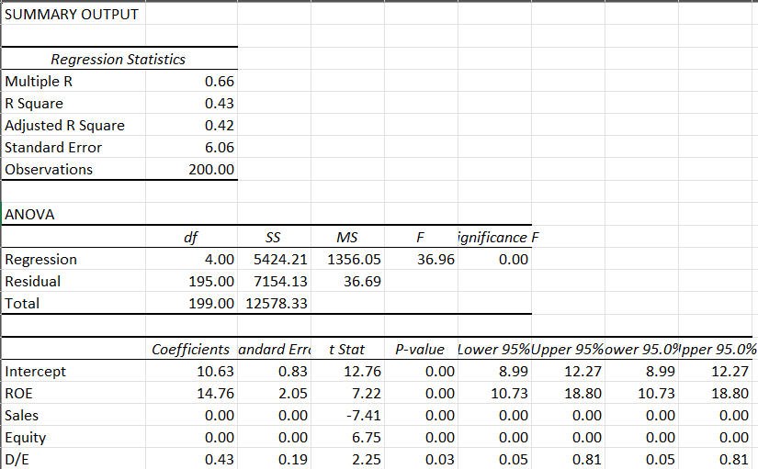

Regression equation-
$$\boxed{NPM=α+β_{1}(\text{ROE})+β_{2}(\text{Sales})+β_{3}(\text{Equity})+β_{4}(\text{D/E})+ε}$$
And numerically:
$$\boxed{NPM=10.63+14.76(ROE)-0.00(Sales)+0.00(Equity)+0.43(D/E)}$$
Interpretation of Regression-
- Multiple R = 0.66: This represents the correlation between the predicted and actual values of the dependent variable (NPM). A value of 0.66 indicates a moderately strong positive relationship between profitability and the chosen independent variables.
- R Square = 0.43: About 43% of the variation in Net Profit Margin (NPM) is explained by the independent variables (ROE, Sales, Equity, D/E). This shows the model has a moderate explanatory power, which is quite acceptable in financial research, as profitability is influenced by multiple external factors beyond capital structure.
- Adjusted R Square = 0.42: This value adjusts for the number of predictors in the model. The fact that it is close to R² means the independent variables used (ROE, Sales, Equity, D/E) are meaningful and not just adding noise.
- Standard Error = 6.06: This indicates the average distance of observed profitability values from the regression line. A lower value is better, and here it shows a reasonable model fit.

The application of regression analysis satisfies the analysis requirement of this study, as it effectively explains the relationship between capital structure variables and profitability. The statistical significance of the results confirms that the model is appropriate and adequate for drawing meaningful conclusions.
The model shows that profitability (NPM) is significantly influenced by capital structure and firm-specific financial indicators. ROE and Equity have the strongest positive contributions to profitability, while Sales has a negative effect. The D/E ratio shows a modest positive effect, suggesting that leverage helps profitability only up to a point.
Thus, the results provide evidence that capital structure decisions, particularly maintaining a balanced debt-equity mix and improving ROE, are crucial for enhancing profitability in Indian companies.

Findings and Recommendations-
- ROE has a strong positive effect on profitability, indicating that companies delivering higher returns to shareholders also maintain stronger profit margins.
- Equity significantly improves profitability, suggesting that firms with a solid equity base are more financially stable and perform better.
- Sales show a negative relationship with profitability, which implies that larger firms do not always achieve higher margins due to higher costs or operational inefficiencies.
- Debt-to-Equity ratio has a moderate positive effect, showing that a balanced level of debt enhances profitability, though excessive leverage may not be beneficial.

Recommendations-
- Companies should focus on strengthening equity financing to maintain financial stability and improve profitability in the long run.
- Managers need to use debt cautiously, maintaining an optimal capital structure that balances the benefits of leverage with the risks of financial distress.
- Firms should improve operational efficiency, as higher sales alone do not guarantee profitability, and better cost management can convert revenues into stronger margins.
Conclusion-
The company chooses to use debt and equity in its capital structure which really matters for its profits and future growth. The study had taken 20 big Indian companies from different industries over 10 years and found that having strong equity and high returns for shareholders helps the company stay stable and make better profits. Using some debt can also help increase profits, but too much debt makes things risky and can lead to financial trouble. The results showed that just having high sales doesn’t guarantee good profits at the same time companies need to be efficient and manage their costs well to actually see higher margins.
So, to be successful, Indian companies should not depend only on getting bigger or taking on a lot of loans but should balance their use of debt and equity and keep improving how they operate. These findings help managers make smarter decisions about financing, help investors choose stable companies, and can even guide policymakers in making better rules for the business world.

References-
https://www.fm-kp.si/zalozba/issn/1581-6311/9-4.pdf#page=57
http://www.annals.seap.usv.ro/index.php/annals/article/viewArticle/487
https://www.screener.in/

